8.17: The change in velocity is the negative of the change in Gretzky’s momentum, divided by the defender’s mass, or

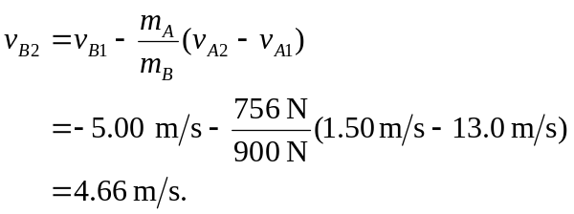

Positive velocities are in Gretzky’s original direction of motion, so the defender has changed direction.

b) 